Step 1A ConsoleAppliation1

Install Visual C++

Create a project

1. Menu –File-> New-> Project

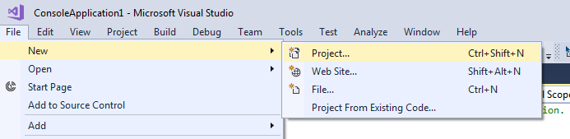

2. Create a Windows Console Application and select the folder

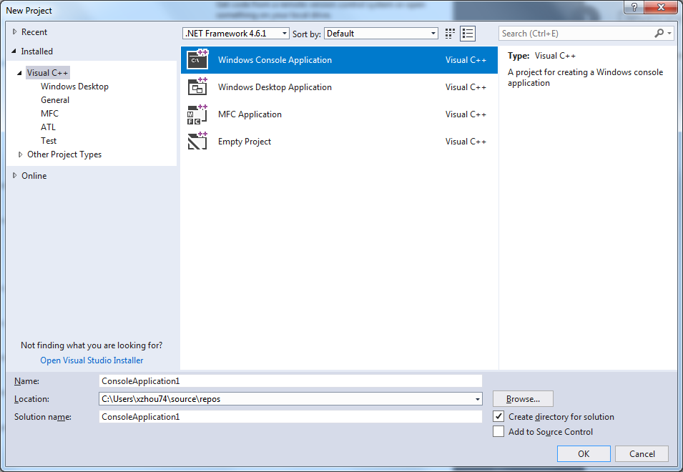

3. Check the main function and in CPP file, and build an executable

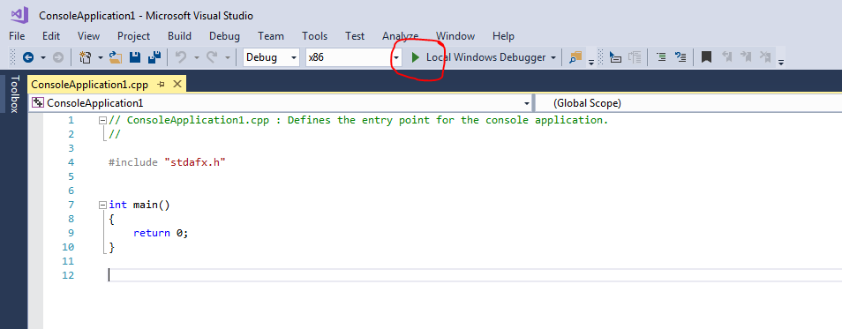

1. Print out hello world

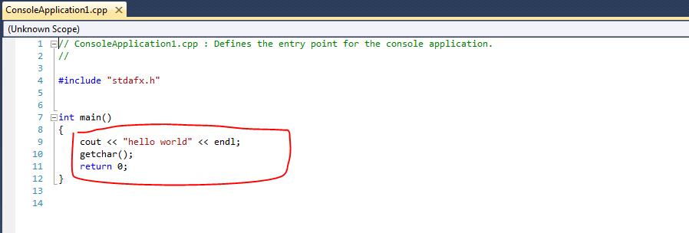

1. Understand stdafx precompiled header

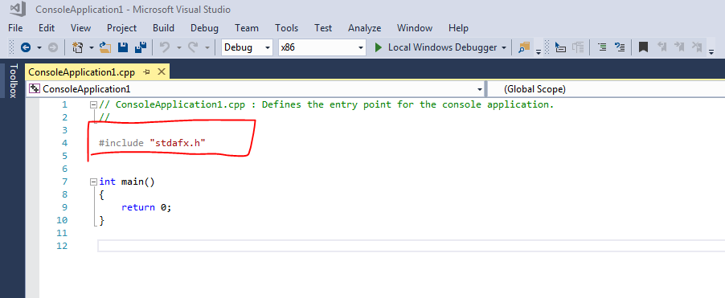

1. Understand solution files

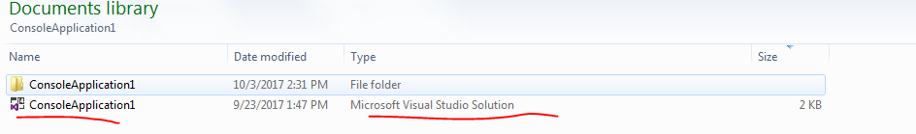

Understand and source files

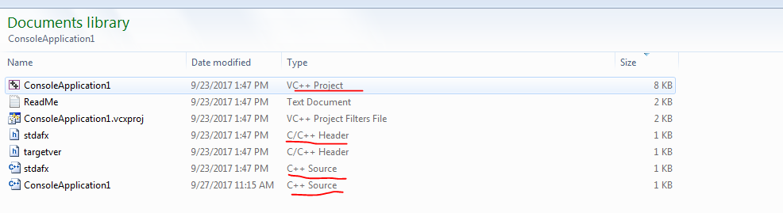

1. Where are executables

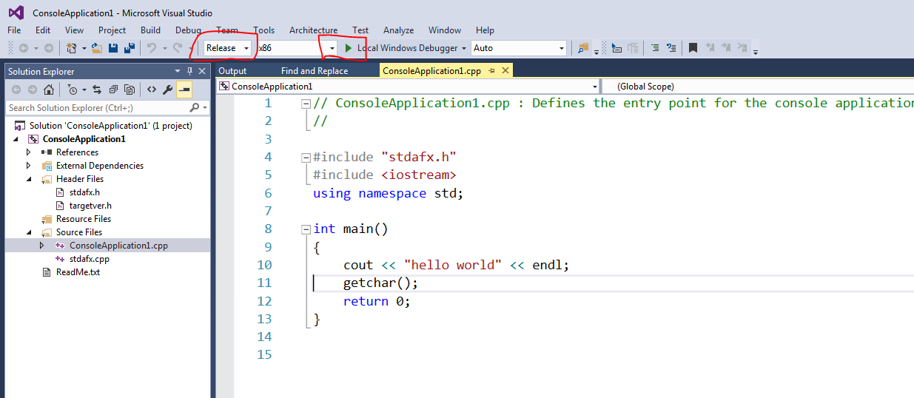

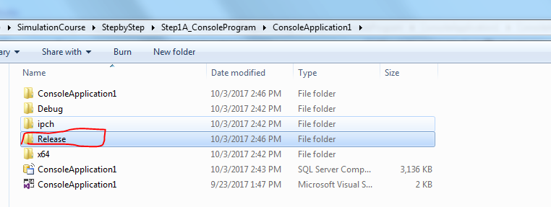

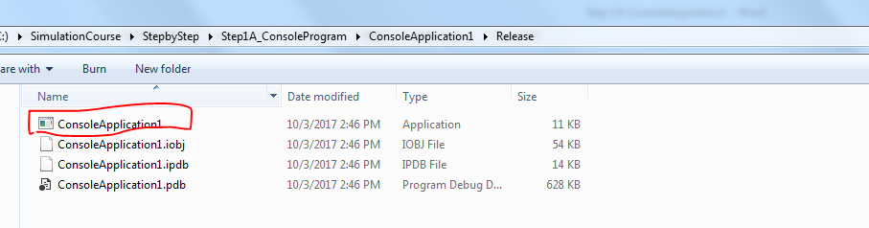

1. Debug vs. release

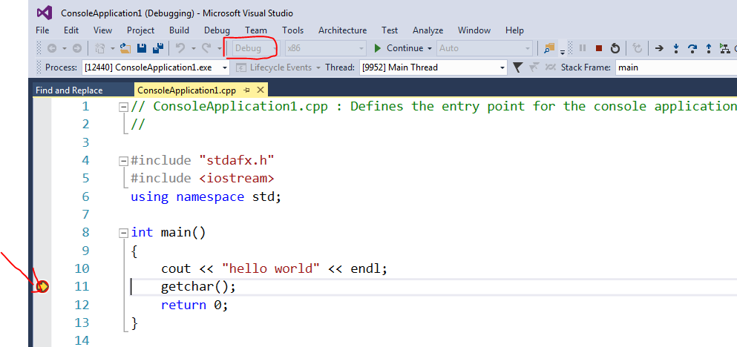

1. How to use the debugging tools, set the break points

